MAINTAINCE SHEET FOR GC-NET v3
Station name: | KAN_U |  | Date: | 06-05-2026
People present: | RSF, RABNI, IASTE, ARU, ASNOR |  | Maintenance |  | Install | Take-down | Data Download

Weather: | Sunny, high clouds

METADATA
 | Arrival | Departure
Download Data | YES / NO | NA
Time difference between logger and UTC (± mm:ss) | 0:11 | 0:0
Screenshot of ‘Status’ table | YES / NO | YES / NO
Screenshot of ‘Public’ table in FastScan mode | YES / NO | YES / NO
Photos of mast, loggerbox and sensors (inc. radiometer serial) | YES / NO | YES / NO

STATION POSITON AND OREINTATION
 |  |  | Arrival |  | Departure
Lower lufft height (see A) |  |  | 297 cm |  | 265 cm
Lower SR50 height (see A) |  |  | 270 cm |  | 222 cm
Upper lufft height (see A) |  |  | 422 cm |  | 390 cm
Upper SR50 height (see A) |  |  | 395 cm |  | 347 cm
Upper boom direction (towards radiometer, see B) |  |  | 334 degree mag. |  | 334 degree mag.
Lower boom direction (towards lufft, see B) |  |  | 244 degree mag. |  | 244 degree mag.
Upper wind sensor orientation (away from black box, see C) |  |  | Yes |  | Yes
Lower wind sensor orientation (away from black box, see C) |  |  | Yes |  | Yes
Radiometer across-boom tilt, looking at the front (see D) |  |  | NA |  | 2 degree to east
Mast tilt north-south axis |  |  | 5 degree down-north |  | 0 degree
Mast tilt east-west axis |  |  | 2.5 degree to left/west |  | 0 degree
Height of thermistor string pipe above surface |  |  | NA |  | 275 cm
Depth of snowboard | 60 cm | Height of snowboard stake |  | 82 cm Vertical: YES / NO
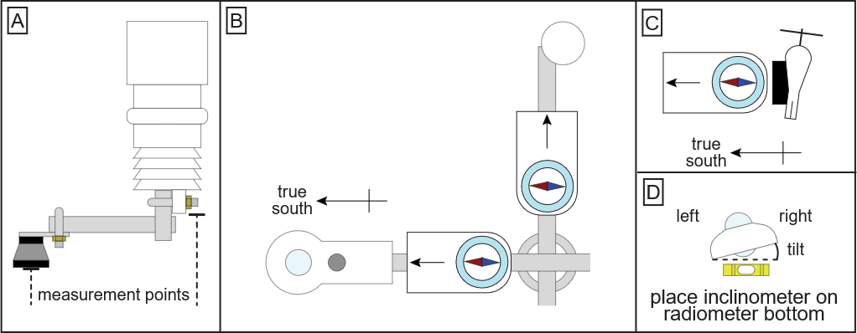

Station name: | KAN_U |  | Date: | 06-05-2026
STATION HARDWARE
To do? | Done? | Item | Comments
Update program | yes | Loggerbox | ID arrival: M3 – 07  ID departure: M3-07
 |  | Modem IMEI | IMEI arrival: 300534062415410  IMEI departure: 300534062415410
 |  | Radiometer | Serial arrival: 202703  Serial departure: 202703
Replace | Yes | Wind sensor upper | Type arrival: Black / White  Type departure: Black / White
Replace | Yes | Wind sensor lower | Type arrival: Black / White  Type departure: Black / White
Replace | Yes | Lufft upper
Replace | Yes | Lufft lower
Replace | No | SR50 upper | Reused old sensor
Replace | Yes | SR50 lower
Replace | Yes | Thermistor string | Installed new thermistor string
Replace | Yes | Iridium antenna | Cable broke during maintenance
 |  | Solar panel
 |  | Battery box | Burial under lower lufft: YES / NO  Location if NO:
Replace | Yes | Mast | Reused old top section

NOTES (e.g. sensor damage, must-do at next visit)
We had no extension cable for thermistor, so we installed a new.
New snowboard top 142 cm, bamboo stick: 216 cm
Liquidice GNSS installed

